Volatility correlation: EURUSD and USDJPY
Method 25 / daily |log returns| / rho_vol / Alpari D1 full available history (realized deferred)

Study setup
Logical pair: EURUSD , USDJPY
Broker symbols: EURUSD_i , USDJPY_i
Snapshot: 2026-11-03_majors_alpari_D1
Timeframe: D1
Matched return window: 1999-01-05 to 2026-11-02 (UTC bar dates)
Matched return count n: 7200
Dropped unfinished last bar dated 2026-11-03 UTC after a tick-volume check against the prior complete day.
Statistic: rho_vol = Corr(|log return_L|, |log return_R|)
rho_realized: not computed (no intraday buckets in this snapshot)
Complete matched rows (Excel): EURUSD-USDJPY_Vol_D1.xlsx
Complete matched rows (HTML table): EURUSD-USDJPY_Vol_D1_data.html

Method carried forward
Volatility correlation rho_vol = Corr(|x_t|, |y_t|) measures whether absolute daily log returns of close move together in size, regardless of sign. Quotes are not inverted. Same-sample signed Pearson r is a side check. The formula sheet also defines within-day realized correlation rho_realized,d from intraday buckets; this v001 uses the Alpari D1 snapshot only, so rho_realized is not computed (no intraday buckets). This is not causation and not a trading signal.

Results (headline)
rho_vol: 0.289809
Pearson r (signed): -0.300952
mean |EURUSD|: 0.00429665
mean |USDJPY|: 0.00444691
rho_realized: n/a (D1-only snapshot)

Conclusion
Headline rho_vol for EURUSD and USDJPY: 0.2898. Signed Pearson r = -0.3010. Mean |return|: 0.004297 (EURUSD), 0.004447 (USDJPY). rho_realized not computed (D1 snapshot has no intraday buckets). This is absolute-move co-movement, not a trading signal.

Charts
Daily closes

Daily log returns

Absolute returns scatter
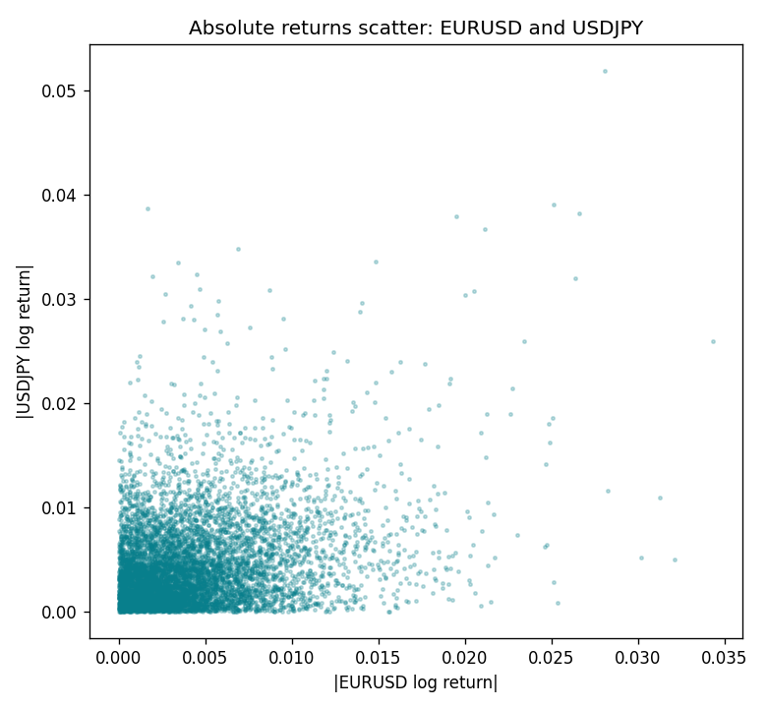

Data report
Matched rows are in the sibling Excel workbook named EURUSD-USDJPY_Vol_D1.xlsx. Embedding all rows as a Word table is impractical; this file holds column summaries and the first and last 15 matched rows.
Columns: time, EURUSD_open, USDJPY_open, EURUSD_high, USDJPY_high, EURUSD_low, USDJPY_low, EURUSD_close, USDJPY_close, EURUSD_tick_volume, USDJPY_tick_volume, EURUSD_spread, USDJPY_spread, EURUSD_real_volume, USDJPY_real_volume, EURUSD_log_return, USDJPY_log_return, EURUSD_abs_return, USDJPY_abs_return
Column summaries (matched calculation rows)
column | count | mean | std | min | 25% | 50% | 75% | max
EURUSD_open | 7200 | 1.1812699 | 0.15089907 | 0.8272 | 1.086045 | 1.16609 | 1.2939325 | 1.5995
USDJPY_open | 7200 | 113.80877 | 19.206548 | 75.693 | 104.4225 | 110.983 | 120.69125 | 163.824
EURUSD_high | 7200 | 1.1864006 | 0.15149686 | 0.8326 | 1.0901575 | 1.17121 | 1.2991625 | 1.6038
USDJPY_high | 7200 | 114.3063 | 19.268128 | 76.001 | 104.878 | 111.441 | 121.26 | 163.978
EURUSD_low | 7200 | 1.1762568 | 0.15022122 | 0.8227 | 1.0819775 | 1.162475 | 1.288265 | 1.5865
USDJPY_low | 7200 | 113.28572 | 19.134551 | 75.402 | 103.8875 | 110.53 | 120.17 | 163.628
EURUSD_close | 7200 | 1.1813075 | 0.15087411 | 0.8267 | 1.085995 | 1.16602 | 1.2939425 | 1.5997
USDJPY_close | 7200 | 113.82186 | 19.221964 | 75.811 | 104.4165 | 111.023 | 120.6855 | 163.851
EURUSD_tick_volume | 7200 | 103020.56 | 173417.03 | 218 | 9398.5 | 52714 | 99443.25 | 1471626
USDJPY_tick_volume | 7200 | 106139.77 | 179306.98 | 149 | 9927.5 | 53095 | 92761 | 1803508
EURUSD_spread | 7200 | 19.389444 | 16.57873 | 0 | 8 | 12 | 30 | 50
USDJPY_spread | 7200 | 20.3175 | 17.636173 | 0 | 6 | 11 | 30 | 50
EURUSD_real_volume | 7200 | 4.0252061e+10 | 1.6676396e+11 | 0 | 0 | 0 | 0 | 3.6149665e+12
USDJPY_real_volume | 7200 | 3.4708591e+10 | 1.6077621e+11 | 0 | 0 | 0 | 0 | 3.8834203e+12
EURUSD_log_return | 7200 | -1.012e-05 | 0.00580063 | -0.03123819 | -0.0032472 | 0 | 0.00325137 | 0.03433183
USDJPY_log_return | 7200 | 4.989e-05 | 0.00620383 | -0.03908203 | -0.00319719 | 0.00011638 | 0.00340925 | 0.05184024
EURUSD_abs_return | 7200 | 0.00429665 | 0.00389663 | 0 | 0.00145787 | 0.00325072 | 0.00596274 | 0.03433183
USDJPY_abs_return | 7200 | 0.00444691 | 0.00432576 | 0 | 0.0014325 | 0.00330541 | 0.00619253 | 0.05184024
First 15 matched rows (selected columns)
time | EURUSD_log_return | USDJPY_log_return | EURUSD_abs_return | USDJPY_abs_return
1999-01-05 | -0.0048360507 | -0.00017868311 | 0.0048360507 | 0.00017868311
1999-01-06 | -0.011547966 | 0.0075660159 | 0.011547966 | 0.0075660159
1999-01-07 | 0.0076280636 | -0.012851583 | 0.0076280636 | 0.012851583
1999-01-08 | -0.010902799 | -0.0047719894 | 0.010902799 | 0.0047719894
1999-01-11 | -0.007103287 | -0.016195423 | 0.007103287 | 0.016195423
1999-01-12 | 0.0045103728 | 0.032310364 | 0.0045103728 | 0.032310364
1999-01-13 | 0.010845346 | 0.0081373171 | 0.010845346 | 0.0081373171
1999-01-14 | 0 | 0 | 0 | 0
1999-01-15 | -0.010153245 | 0.0055343401 | 0.010153245 | 0.0055343401
1999-01-18 | 0.0036256946 | 8.7600193e-05 | 0.0036256946 | 8.7600193e-05
1999-01-19 | -0.00017235436 | -0.0056219403 | 0.00017235436 | 0.0056219403
1999-01-20 | -0.0031939256 | -0.0053879917 | 0.0031939256 | 0.0053879917
1999-01-21 | 0.0030215416 | 0.0084664056 | 0.0030215416 | 0.0084664056
1999-01-22 | -0.0012075213 | 0.0060412564 | 0.0012075213 | 0.0060412564
1999-01-25 | -0.0030251979 | -0.0073594164 | 0.0030251979 | 0.0073594164
Last 15 matched rows (selected columns)
time | EURUSD_log_return | USDJPY_log_return | EURUSD_abs_return | USDJPY_abs_return
2026-10-13 | 0.0037402957 | -0.0018932826 | 0.0037402957 | 0.0018932826
2026-10-14 | -0.0037582255 | 7.5800166e-05 | 0.0037582255 | 7.5800166e-05
2026-10-15 | 0.0056053107 | -0.0018524319 | 0.0056053107 | 0.0018524319
2026-10-16 | 0.0017724895 | -0.00037976126 | 0.0017724895 | 0.00037976126
2026-10-19 | -0.0025394633 | 0.0034946841 | 0.0025394633 | 0.0034946841
2026-10-20 | 0.0023881672 | -0.0022546642 | 0.0023881672 | 0.0022546642
2026-10-21 | -0.00032046717 | -0.00032883504 | 0.00032046717 | 0.00032883504
2026-10-22 | -0.0015949606 | -0.0085942669 | 0.0015949606 | 0.0085942669
2026-10-23 | -0.001338521 | 0.00035080446 | 0.001338521 | 0.00035080446
2026-10-26 | -0.0022706559 | 0.0041238746 | 0.0022706559 | 0.0041238746
2026-10-27 | -0.004152342 | 0.0027651658 | 0.004152342 | 0.0027651658
2026-10-28 | 0.0022262927 | -0.00095679538 | 0.0022262927 | 0.00095679538
2026-10-29 | 0.0022571351 | -0.00038043789 | 0.0022571351 | 0.00038043789
2026-10-30 | -0.0011458446 | -0.0010596481 | 0.0011458446 | 0.0010596481
2026-11-02 | 0.002120569 | 0.0026438521 | 0.002120569 | 0.0026438521

